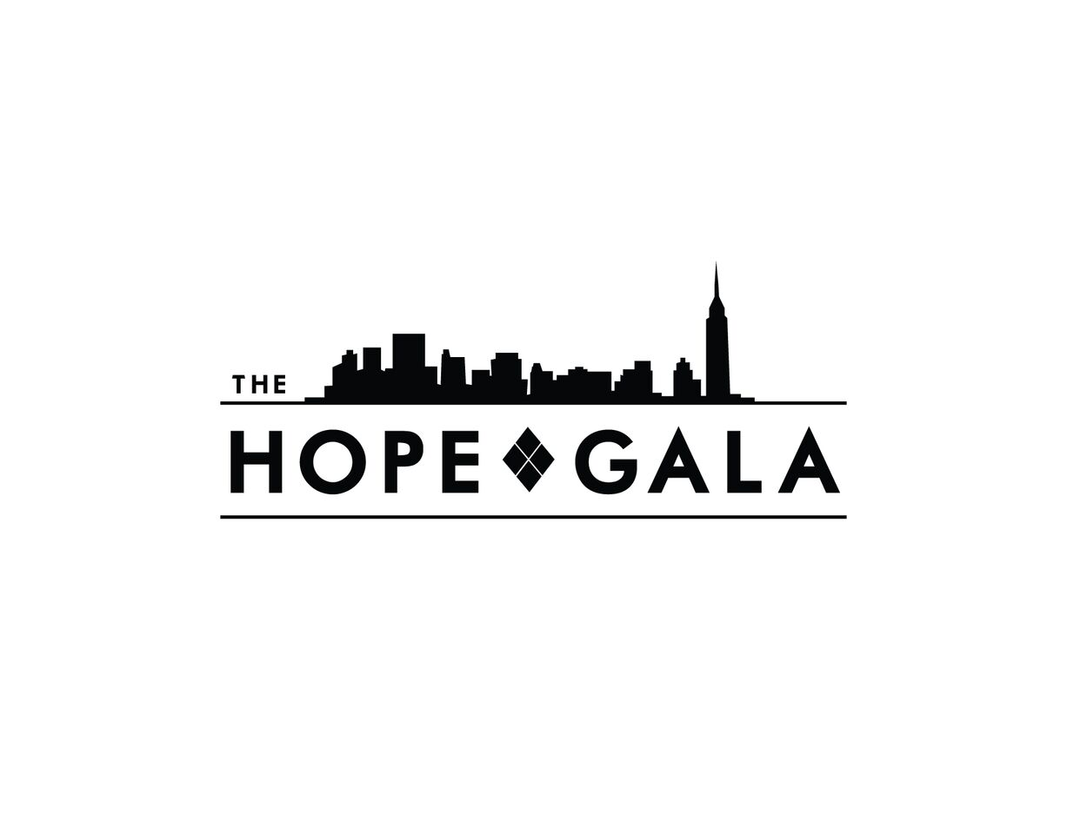
How to get started:

- If you have a mini-event promotion or idea in mind, please send an email with your idea to the Mini- Event Directors, Katrina Perez katrina@nychopegala.com & Ally Zimmerman ally@nychopegala.com and our Volunteer Director, Mannat Parmar mannat@nychopegala.com. The team would like to help you reach your fundraising goals and have a variety of locations and ideas to suggest based on the activity you’re planning.

- Once confirmed, please send us the following information on the event:
  - Event Name:
  - Location:
  - Contact at venue:
  - Time:
(We suggest promoting your event approximately 6- 10 weeks in advance so it can be incorporated into newsletters and so the word can spread!)
  - Description:
(This should be a brief description of the event for us to use in promoting the event)
  - Any specific requests / additional details about the event:
(If you plan to run a raffle you may need a roll of raffle tickets, etc.)

- Promotion:
  - The Hope Gala will promote your event through the Volunteer Newsletter one month prior the event itself.
  - THON is now promoting Alumni events - you can apply here: https://ext.think.thon.org/?model=ThirdPartyFundraiserApplication

- Social Media Approval Process: Once your Facebook or other social media sites are set up, please send the page to contact@nychopegala.com for approval. We will get back to you ASAP.
  - Logo Use: Our approved logos can be found here: https://www.dropbox.com/s/yhwfyw04jbz0yds/HG%20-%20Logo%20-%20Black%20-%20Standard.jpg?dl=0
  - The Hope Gala’s Mission Statement: “The Hope Gala is committed to conquering childhood cancer by raising awareness, providing financial assistance, and supporting the fundraising efforts of Penn State Dance Marathon (THON), which benefits Four Diamonds, through our annual gala and year-round fundraising.”
  - The Hope Gala’s About Us: “The Hope Gala is an annual gala and year-round fundraising organization established to support the fundraising efforts of Penn State Dance Marathon (THON). Since 2008, The Hope Gala has raised over $600,000 towards the mission of conquering childhood cancer. Four Diamonds is the sole beneficiary of THON's fundraising activities and THON is the largest contributor to Four Diamonds. All proceeds benefit childhood cancer patients and their families in need of financial aid, medical assistance, and emotional support at the Penn State Hershey Children’s Hospital. The Hope Gala was founded by the New York City Chapter of the Penn State Alumni Association with support from the Northern New Jersey Chapter.”

Frequently Asked Questions:
- Hope Gala is not able to financial support the event.
- The event does not need to be in NYC.
- The amount raised will be contributed to your fundraising total if you are aiming to raise $1,000 for a free ticket.
- You can work with a friend (or a group of friends) to plan an event.
- Depositing funds:
  - Checks can be sent to 487 Keap St, #501, Brooklyn, NY 11211
  - Any cash should be handed off to a Director
- The Hope Gala is eligible for employee matching opportunities
- The Hope Gala is a qualified 501(c)(3) tax-exempt organization. All financial gifts are tax-deductible to the maximum extent allowed by law. Tax ID number is available upon request.

Volunteer Mini-Event Ideas:
- Bingo Night
- Bowling Night
- Comedy Show
- Exercise class (SoulCycle, Flywheel, Yoga, etc.)
- Happy Hour
- Karaoke Night
- NCAA Basketball Pool
- Paint night
- Trivia
- Wine / Whiskey Tasting

